Contents

1. GIT Installation Process 2

Upgrade Visual Studio 2

Install Git Extension 2

Verify installation 3

2. Adding Source code to GIT 4

3. Development workflow 9

## GIT Installation Process

### Upgrade Visual Studio

Installing GIT extension requires that Visual Studio be updated first. Go to <http://go.microsoft.com/fwlink/?LinkId=273878> and download the installer.

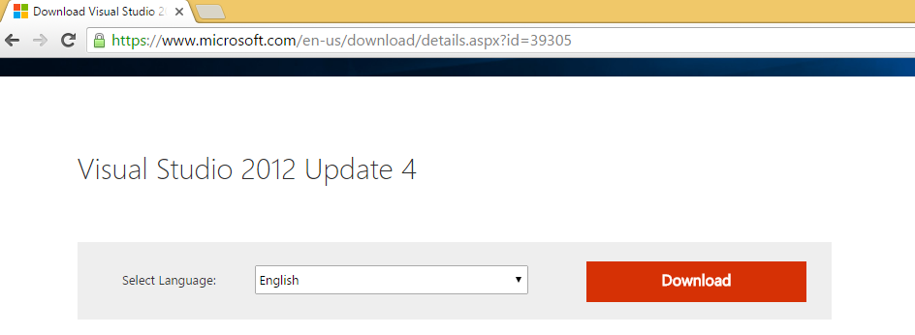

Approx. 6 GB of free space is required for the update and the installation will run for several hours.

### Install Git Extension

Once visual studio is updated we are ready to install Git Extension. Go to <https://visualstudiogallery.msdn.microsoft.com/abafc7d6-dcaa-40f4-8a5e-d6724bdb980c> and download the installer.

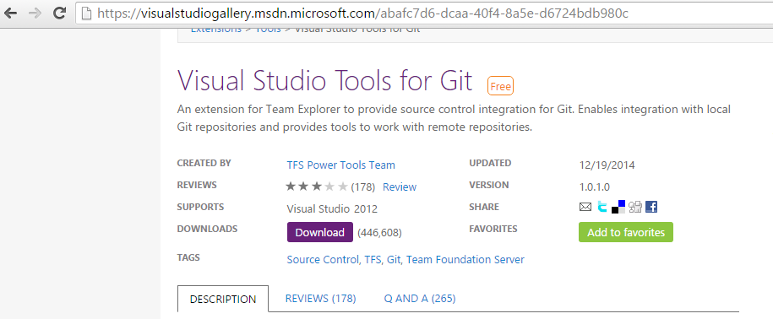

The installer is an .msi file. Try to install the file, if you get admin rights error, follow below instructions:

While running this file we encountered error saying “the admin has restricted installation of this type of file…” . The .msi file does not have option to run as administrator. So we have to go to Command Prompt, right click and then ‘run as administrator’. From the command prompt run the .msi file. Now it should install without errors.

### Verify installation

Once the extension is installed, open Visual Studio. Visual Studio will look lie 2015 version due to update. Go to View-> Team Explorer. Now you should be able to see Git options under Team Explorer window.

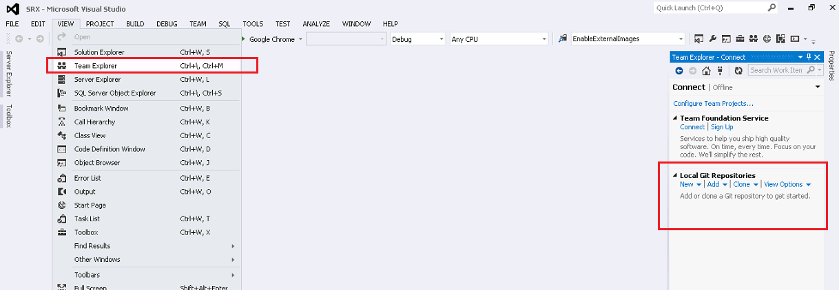

## Adding Source code to GIT

Use the Clone option. Provide the GIT URL in first input box and GIT folder path in second input box. Note: new folder “GIT” is created for this purpose.

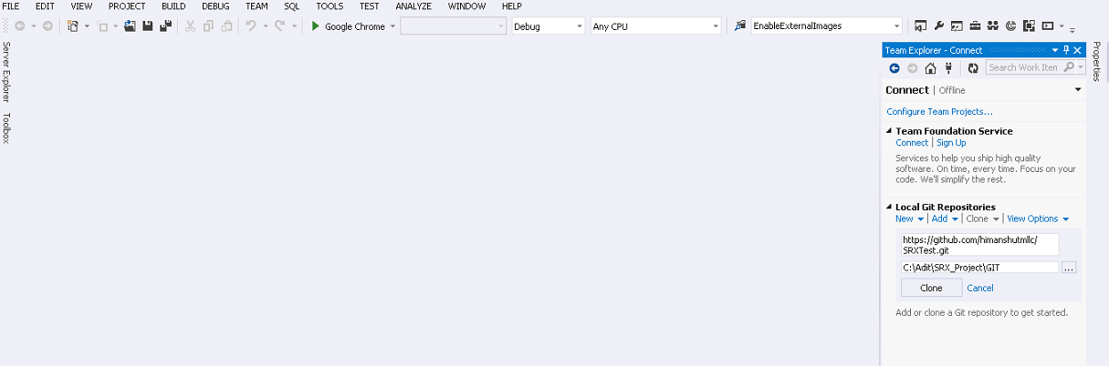

Provide username and password in the next screen.

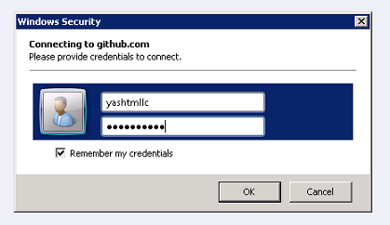

Now you will be able to see the Git Repository in team explorer

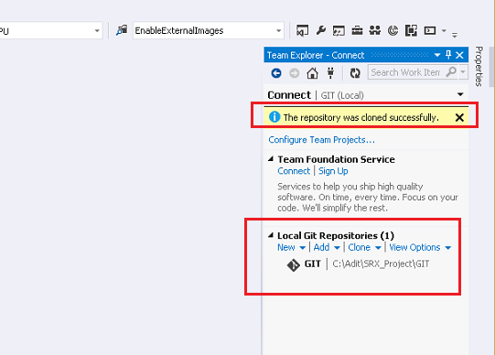

Now copy the source code in GIT folder. (T**his is one time activity, not to be repeated on all machines. For other workstations, just clone the repository.**)

Click on Sync

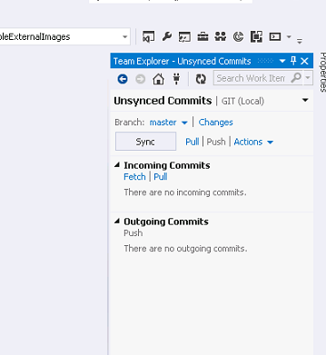

It will ask to configure username and password.

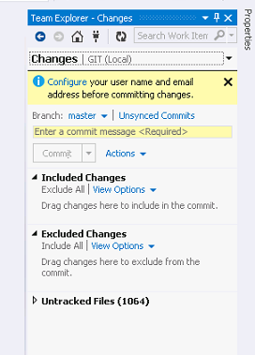

Enter username and email

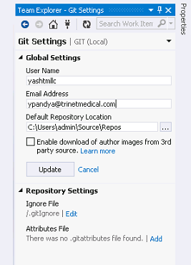

Go to Untracked changes and select **Add All.** After that all files will appear in Included changes.

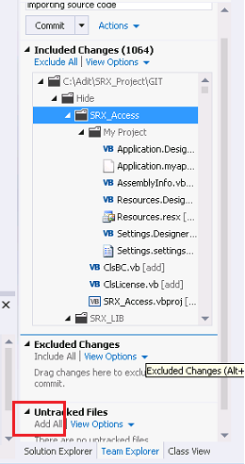

Provide comment and Commit. Use the **Commit and Sync** optioninstead of just commit. After the commit and sync is completed you will see the following message.

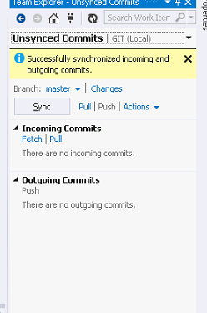

Now you should be able to see Git symbols for each file and folder. They indicate whether a file is in sync with the repository or a commit is pending. If you do not see these symbols restart Visual Studio.

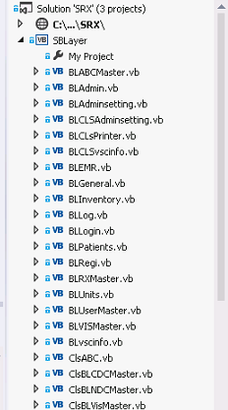

Also install command prompt. It will be handy in case some options are not available in Visual Studio.

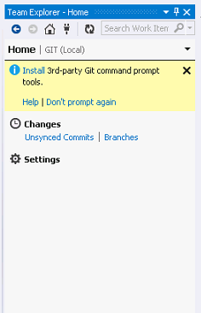

## Development workflow

In Git, there is a main branch called **master**. The Git philosophy is that the master should always be deployable. Hence if any feature addition or bug fixing is required then it should be done on a **branch**. When the changes are done and stable, they will be merged with the master.

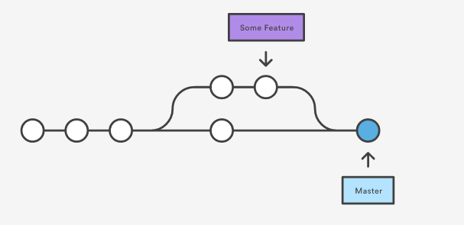

Different versions for different clients can be managed on different branches. These branches will never be merged with the master but will continue as branch throughout their lifetime. We can call them “client branches”

Any changes on these “client branches” will have to be done by creating branches on them and then merging back to client branches.

You can change a branch or create a new branch as desired. 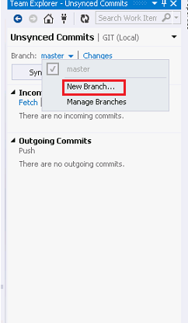

When a branch is created from master, it will have all the files from master. However any changes made in master after the branch is created will not be reflected in Branch. For example: the changes c and d will not be reflected in ‘my-branch’



Fortunately Git provides a solution for the same. You can rebase the branch from master. Once you rebase the latest changes of master will be updated to the branch.



To rebase use the ‘update from master’ option in Git desktop client. TODO: check if similar option is available in visual studio extension.

Pl. refer <https://www.visualstudio.com/en-us/docs/git/gitquickstart> for more details.